

Ant Farm GridWorld Project

Robert Glen Martin
School for the Talented and Gifted, Dallas, TX

Introduction

This is the assignment for Ant Farm, a GridWorld programming project. You have a JCreator starter project contained in the folder named AntFarm Student and Javadoc documentation in the folder named AntFarm Javadocs (index.html). As you work through this project, you will complete an interface and both concrete and abstract classes. Your solution will demonstrate inheritance, encapsulation, and polymorphism. Prior to beginning this project, you must read and understand the first four chapters of the GridWorld Student Manual.

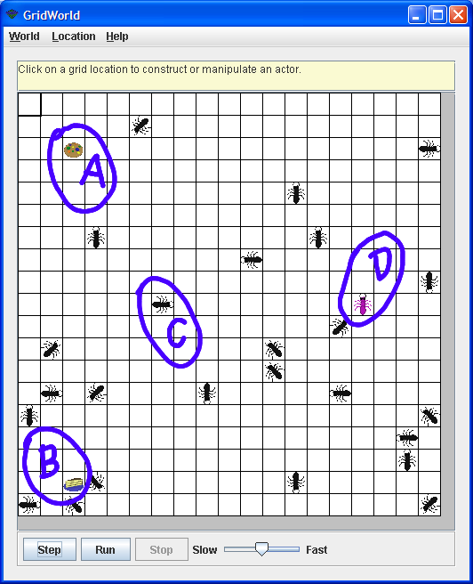
Overview

The project utilizes four new types of objects (see Figure 1), two kinds of food (A - Cookie and B - Cake) and two kinds of ants
(C - WorkerAnt and
D - QueenAnt). Initially, the worker ants walk around in search of food. When they find food, they take a bite. Ants with food turn red. Then the worker ants go in search of a queen ant to give food. Once they give their food to a queen, they turn black and go back to get more food.

Food and queens remain stationary. Worker ants remember the locations of the food and queen. Additionally, they share those locations with other worker ants they meet.

When the Ant Farm program starts, the worker ants are spread around the grid in random locations. Initially, they are disorganized as they search for food. As the worker ants start to find food and the queen, they get more organized (see Figure 2 below). After all the ants learn the locations, they exhibit an emergent behavior that is very organized (see Figure 3 below).
Figure 1 – Ant Farm (Initial State) – Worker ants hunt for food.

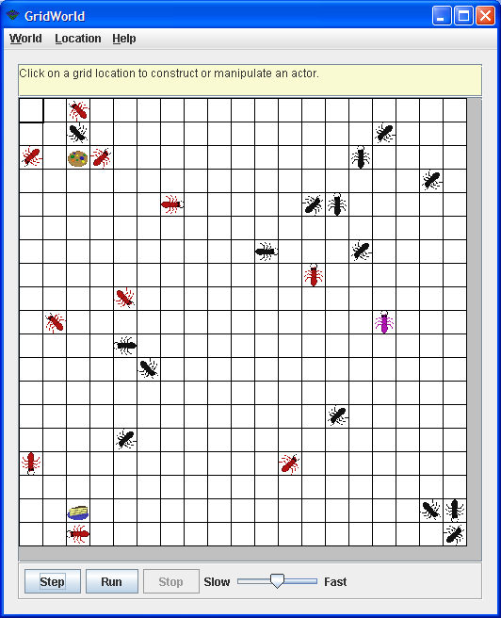
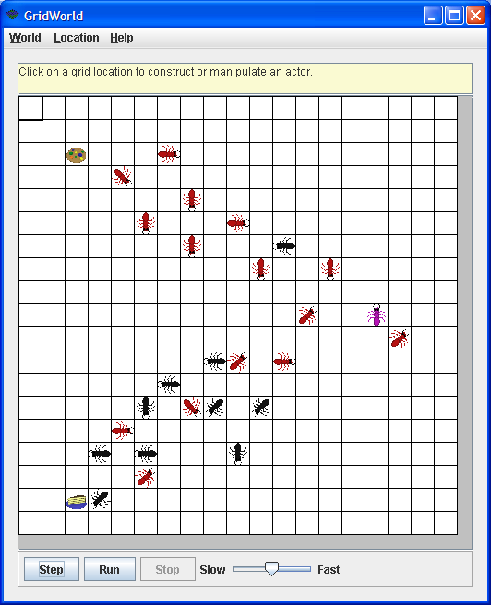
Figure 2 – Intermediate State – worker ants start learning locations of food & queen.

Figure 3 – Final State – worker ants know locations of food & queen.

Program Organization

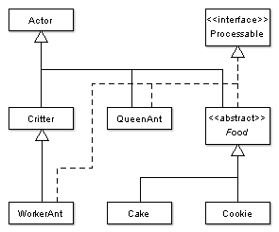
Figure 4 shows the organization of the Ant Farm classes and interface.

GridWorld has a “built-in” Actor class for objects that “live” in the grid. Actors that have minimal interaction with other objects in the grid normally inherit from Actor. This is appropriate for QueenAnt and Food. Cake and Cookie inherit indirectly from Actor.
Figure 4 – Ant Farm Classes
The other “built-in” actor is Critter, which inherits from Actor. Critters have additional methods that are useful for interacting with other actors. WorkerAnts need to “communicate” with the QueenAnt, Cake, Cookie, and other WorkerAnt objects. So inheriting from Critter is appropriate for them.
Ant Farm also has a new Processable interface. This interface has a single process method that is the key to communication between worker ants and the other actors.

Starter Code

Folder AntFarm Student contains a JCreator project with starter code for the Ant Farm interface and classes. AntFarmRunner (the application) is complete and requires no changes. The needed imports, class headings, method headings, block comments, and image (gif) files are provided for the remaining classes. The interface heading and comments are provided for Processable.
Compiling early and often is a good programming practice. It helps identify errors when they are easiest to fix. Compile and execute the project. You should see all the actors on the screen. All the actors are blue at this point. Why?
Note: Clicking the Step or Run button at this point will cause a NullPointerException.

Processable Interface

It is critical that you understand the Processable interface and how it is used in Ant Farm. Examine the Processable.java file. The Processable interface, contains a single void process method. This process method takes one parameter of type WorkerAnt. Add the method heading for process. Note: All interface methods are automatically public and abstract. Compile the project and correct any errors.

When implemented in QueenAnt, Food, and WorkerAnt, the process method processes (communicates with) a single WorkerAnt object (the one passed as a parameter). This interface allows worker ants to invoke the other actor’s process methods polymorphically. The individual process methods in each class will do the following:
- QueenAnt
  - Get food from the worker ant.
  - Give the queen’s location to the worker ant.
- Food
  - Give food to the worker ant.
  - Give the food’s location to the worker ant.
- WorkerAnt
  - Give the saved food location to the other worker ant.
  - Give the save queen location to the other worker ant.

Note that Ant Farm uses the Processable interface to implement an interface variant of the Template Design Pattern. The Template Design Pattern normally uses an abstract class to contain the abstract method(s). Then concrete classes (which inherit from the abstract class) implement the method(s) as appropriate. In Ant Farm, we use the Processable interface to hold the abstract process method. process methods are written in the QueenAnt, Food, and WorkerAnt classes, each of which implement Processable.

QueenAnt Class
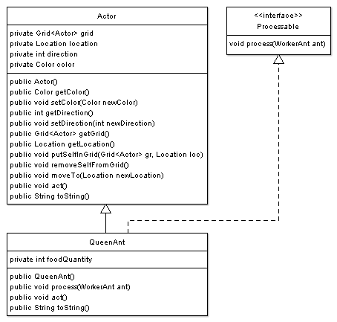
Figure 5 shows the QueenAnt class. Queen ants are the simplest of the new Ant Farm objects.

Start updating QueenAnt by adding the new foodQuantity instance field. It is used to contain the total amount of food that has been given to the queen by the worker ants. You will make all instance fields private to preserve encapsulation.

Write the constructor body. It needs to initialize foodQuantity to 0 and use the inherited setColor method to set the queen’s color to Color.MAGENTA.
Figure 5 – QueenAnt Class

Since QueenAnt implements Processable, you need to write the process method. process needs to get food from the passed worker ant using the WorkerAnt giveFood method. This method, which is shown in Figure 7 below, returns an int amount which should be added to foodQuantity. process also needs to provide the worker ant with queen’s location by calling the WorkerAnt shareQueenLocation method. Write the process method.

The Actor act method needs to be overridden with an empty “do nothing” method (QueenAnts don’t act). Look at QueenAnt to see how this was accomplished. Note the use of the @Override annotation (on the line preceding the act method heading). Although annotations are not included in the AP Java subset, @Override is very helpful. If you accidentally misspell the method name, @Override will cause a compile error telling you about this mistake. This error can be very difficult to find otherwise. The compiler is your friend.
The Actor toString method also needs to be overridden to add additional information to the string returned by Actor’s toString. This provides a good example of using super to call a super class method. Replace the toString body with the following:
return super.toString() +
", FQty=" + foodQuantity;
Compile and execute your project. The queen ant at location (15, 9) should now be magenta. Right-click the queen ant and execute its toString method. You should get “QueenAnt[location=(9, 15),direction=0,color=java.awt.Color[r=255,g=0,b=255]], FQty=0”. Observe that this toString information is also shown when you place your mouse over the queen ant.

Foods - Food, Cake, and Cookie Classes

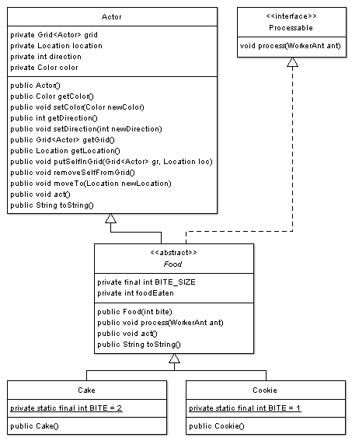
Figure 6 shows the Food, Cake, and Cookie classes. Foods act like queens, but they give food instead of getting it.

Different kinds of food are very similar. They differ only by the size of a bite and the displayed image. To take advantage of this similarity, the common instance fields and methods are placed in a Food super class. This class contains no abstract methods, but it is declared abstract so that it can not be instantiated. All foods have both bite sizes and keep track of the total amount that has been eaten. So, instead of repeating this information in both Cake and Cookie, it is stored in Food instance fields:
Figure 6 – Food, Cake, and Cookie Classes
- BITE_SIZE – a constant that determines how much food is given to a worker ant when it gets food.
- foodEaten – keeps track of the total amount of food “given” to worker ants.

The constructor initializes BITE_SIZE to the bite value passed in the parameter, initializes foodEaten to 0, and calls setColor(null) so that the Cake.gif and Cookie.gif images display with their original coloring.

Update Food to include the two new instance fields and complete the constructor as discussed above. You will need to uncomment the constructor heading and brackets. Note that Java allows constant (final) instance fields to be initialized in a constructor.
Compile your Ant Farm project again. Food should have no errors, but Cake and Cookie now have compile errors. Why? What change caused these errors? We will fix these errors later.
All foods implement the process method (from Processable) to give food to the passed worker ant and to provide it the food’s location. Foods need to override the Actor act method with an empty “do nothing” method (foods don’t act). Foods also need to override the toString method to include the BITE_SIZE and foodEaten information. Since all three of these methods are the same for all foods, they are placed in Food. Otherwise they would have to be written in both Cake and Cookie.

Write the process method (use WorkerAnt’s takeFood and shareFoodLocation methods). Also replace the body of the toString method as discussed above. Don’t forget to include the Actor super class toString information like you did with QueenAnt. Make sure that Food compiles without error.

Because of the Food class, the Cake and Cookie classes are very simple. They contain a single class constant BITE which contains the size of a bite. They each have a one statement constructor which passes the value of BITE to the Food constructor.

Complete the Cake and Cookie classes by adding the BITE class constants (see Figure 6 for the appropriate values).

Complete the Cake and Cookie constructors by adding a single statement - super(BITE); This causes the one parameter Food constructor to be used when a cake or cookie is created.

Compile and execute the project. The cake and cookie should now display properly. They should not be tinted. Hover your mouse above the cake and cookie images to make sure that the toString methods are working properly. For example, the cookie should display
“(2, 2) contains Cookie[location=(2, 2),direction=0,color=null], BSize=1, FEaten=0”
WorkerAnt Class

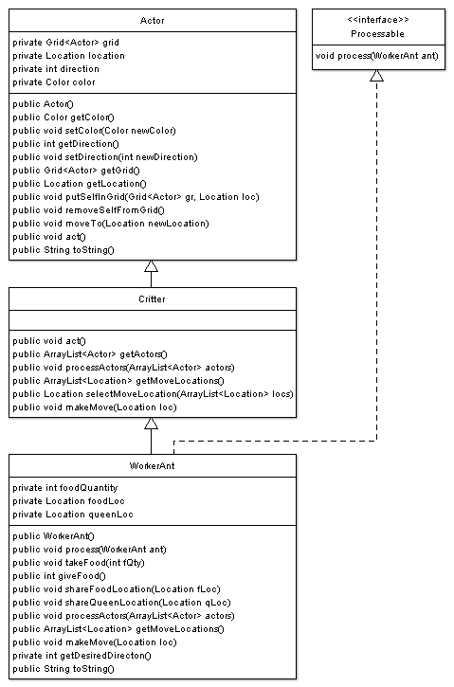
WorkerAnt (Figure 7) is the most complex Ant Farm class. This is to be expected, since Critters interact with other actors in the grid.

Worker ants have instance fields to keep track of the amount of food they currently have as well as known locations of the food and the queen.

The constructor initializes these instance fields (to 0, null, and null), makes the ant black, and uses Math.random to randomly point the ant in one of the eight valid compass directions.

Add the WorkerAnt instance fields and complete the constructor as discussed above and in Figure 7. Use the Location constants HALF_RIGHT and FULL_CIRCLE when writing your constructor. Do not “hard code” constants like 45 and 8. Compile and execute the project to check your code.
Figure 7 – WorkerAnt Class

WorkerAnt implements the process method to share queen and food locations with other worker ants. WorkerAnt has four methods that do the actual “processing.” They are takeFood, giveFood, shareFoodLocation, and shareQueenLocation. These methods are called from the process methods of the QueenAnt, Food, and WorkerAnt classes.

Complete the five processing methods as follows. Make sure that the project compiles after every change.
- process – call the passed worker ant’s shareFoodLocation and shareQueenLocation methods to share the food and queen locations with the other ant.
- takeFood – add the amount of food passed in fQty to the food quantity instance field.
- giveFood – replace the method body to return the current food quantity to the caller (queen). Before giveFood exits, the food quantity needs to be reset to zero (all the food is being given to the queen).
- shareFoodLocation – Foods and worker ants call shareFoodLocation to share the food location. If the current saved food location is null, then set it to the value of qLoc.
- shareQueenLocation – Queens and worker ants call shareQueenLocation to share the queen location. If the current saved queen location is null, then set it to the value of fLoc.

You are about ready to override several of the Critter act methods, but first you will need to complete the useful getDesiredDirecton private helper method. This method returns the general direction that the ant wants to go.
Replace the getDesiredDirecton body to return one of three directions:
- If the queen location is not null and the food quantitiy is not zero, then return the direction from this ant toward the known location of the queen (use Location’s getDirectionToward method).
- Otherwise, if the food location is not null and the food quantity is zero, then return the direction from this ant toward the known location of the food.
- Otherwise, return the current direction of this ant.

The Critter act method calls the following methods in this order:
- getActors – gets a list of actors for interaction.
- processActors – interacts with each of the actors in the list from getActors.
- getMoveLocations – gets a list of possible locations for moving this critter.
- selectMoveLocation – chooses one of the possible move locations for this critter.
- makeMove – moves this critter.

WorkerAnt inherits the Critter act method which does the following:
- Uses the inherited getActors to get all the adjacent neighboring actors.
- processActors processes each of the neighboring ant farm actors. This method should be very short. It needs a loop to traverse (loop through) the actors ArrayList. An enhanced for loop works well for this. Each actor in actors needs to call its process method. The parameter for each call will be this, the reference to the worker ant executing the processActors method.
An actor could be a QueenAnt, a Cake, a Cookie, or a WorkerAnt. Without the Processable interface, processActors would need to determine the type of actor and then downcast the actor reference before making the call to process. But, since each of these classes implements Processable, processActors only needs to cast the actor to Processable before the call. This polymorphic processing is allowed because Processable contains the process abstract method. The Java Run Time Environment (JRE) determines the actual type of object at runtime and calls the appropriate process method.
Complete the processActors method as discussed in the preceeding paragraphs.
- getMoveLocations does the following:
  - Calls the private getDesiredDirecton method to get the general direction the ant wants to move.

  - Creates a list with up to three adjacent locations that are in the general direction of the one returned by getDesiredDirection. Locations are included if they meet all of the following criteria. They must be:
    - Adjacent to the current location.
    - In the desired direction, or 45 degrees to the left of the desired direction, or 45 degrees to the right of the desired direction.
    - Valid (in the grid).
    - Empty.
  - Returns the list of locations.
Replace the getMoveLocations body as discussed above. For part b, use Location’s HALF_LEFT and HALF_RIGHT constants and the getAdjacentLocation method. You will want to use Grid’s isValid to see if a given location is valid (is in the grid) and get to help see if the location is empty (get returns null).
- Uses the inherited selectMoveLocation to randomly select one of the possible locations. If the list of possible locations is empty, it returns the current location.
- If the selected move location is different from the current location, makeMove moves to the selected location and changes its direction to match the direction it moved. Otherwise it stays put and changes its direction by randomly choosing between the two directions 45 degrees to the left or right (use Location.HALF_LEFT and Location.HALF_RIGHT). Then, in either case, it sets its color based on if it has food (red) or not (black).
Write the body of the makeMove method as discussed above.
Complete the toString body to include Critter’s toString result as well as the values of the WorkerAnt instance fields.

Compile and thoroughly test your project. Make sure that your actors behave properly as described in the Overview section at the beginning of this assignment. You can learn a lot about the the state of your actors by viewing their toString information (hover over the object). Make sure this information changes appropriately as your actors interact with each other.

